1. Run the app with your phone or an Android Emulator
2. You should see the “Repositories” page as the starting page

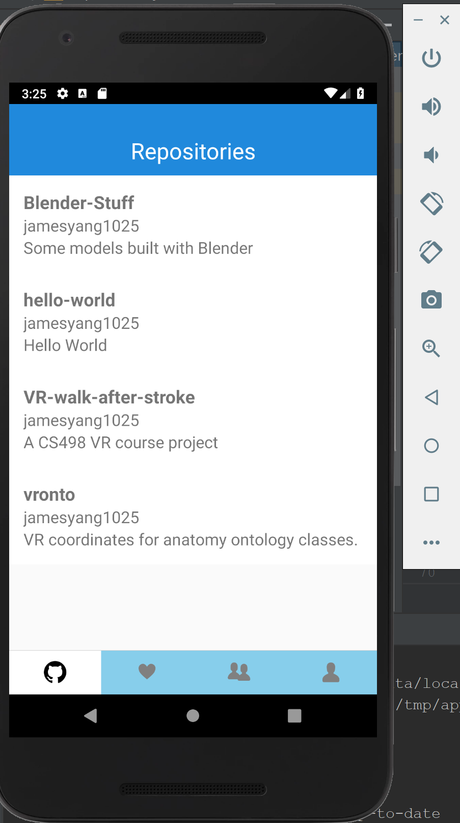

1. You can navigate by using the tabs in the bottom, which navigate to – “Repositories page”, “Following page”, “Followers page”, “Profile”, respectively.
2. In the “Repositories page”, You can see the list of public repositories.
3. You can click on any of the repository which will direct to the corresponding page. For example, click on VR-walk-after-stroke and it will direct you to the repo page. You can scroll down or go deeper to explore the repository.

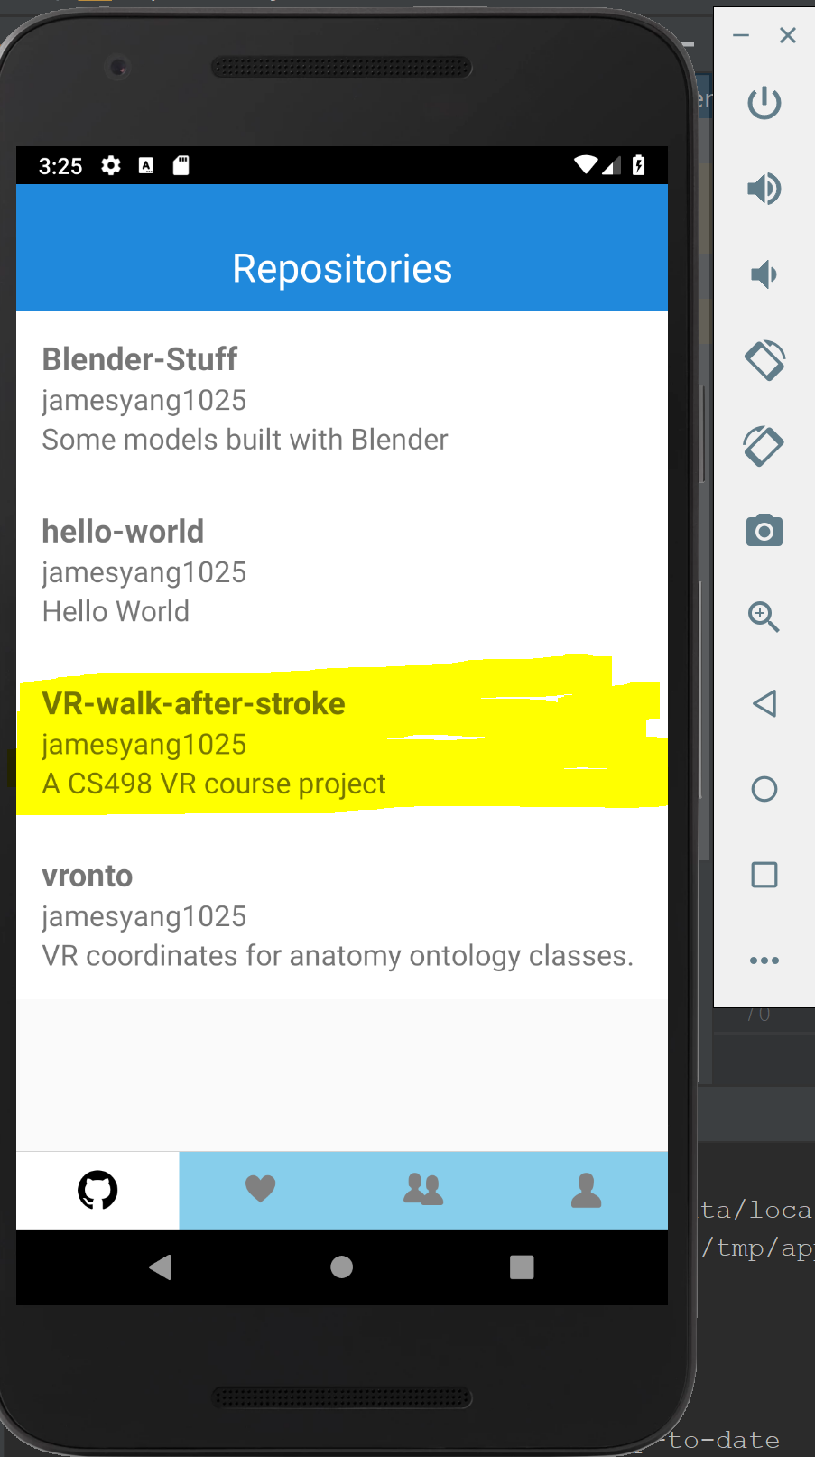 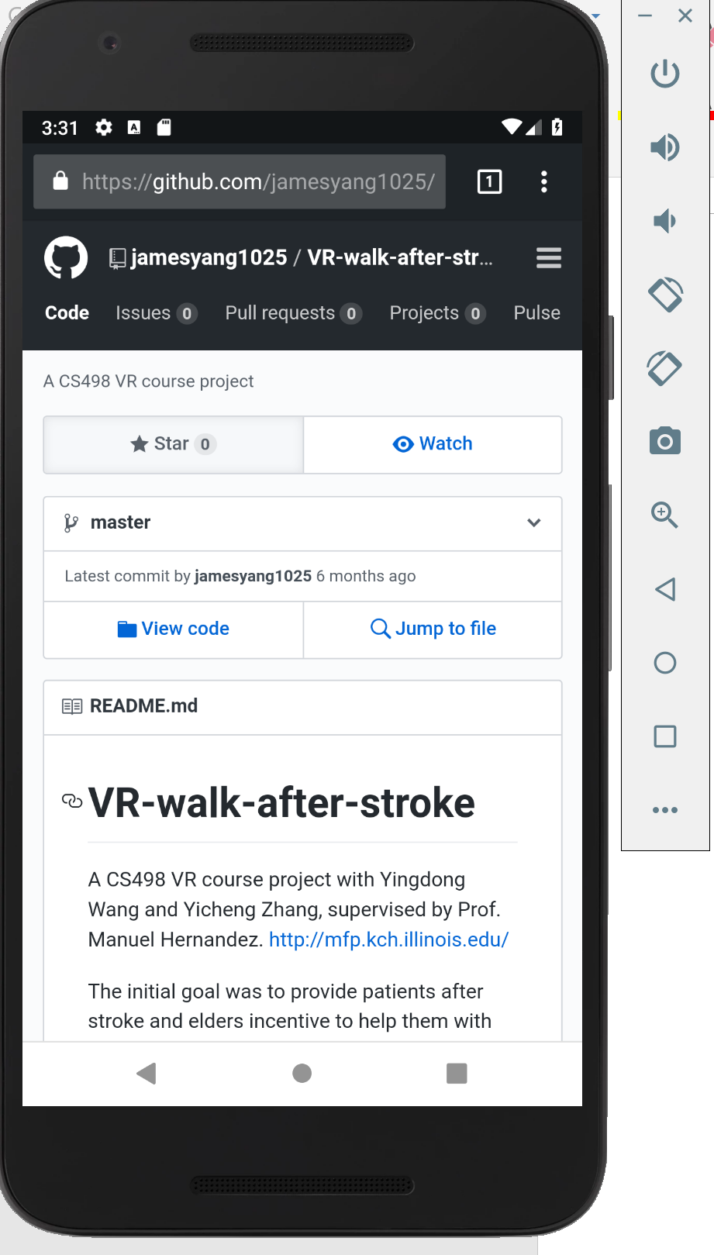



1. Click the return button on the button to return to the app.



1. Click the “Following” tab, which would direct you to the “Following page”. But at this stage, this page is empty.

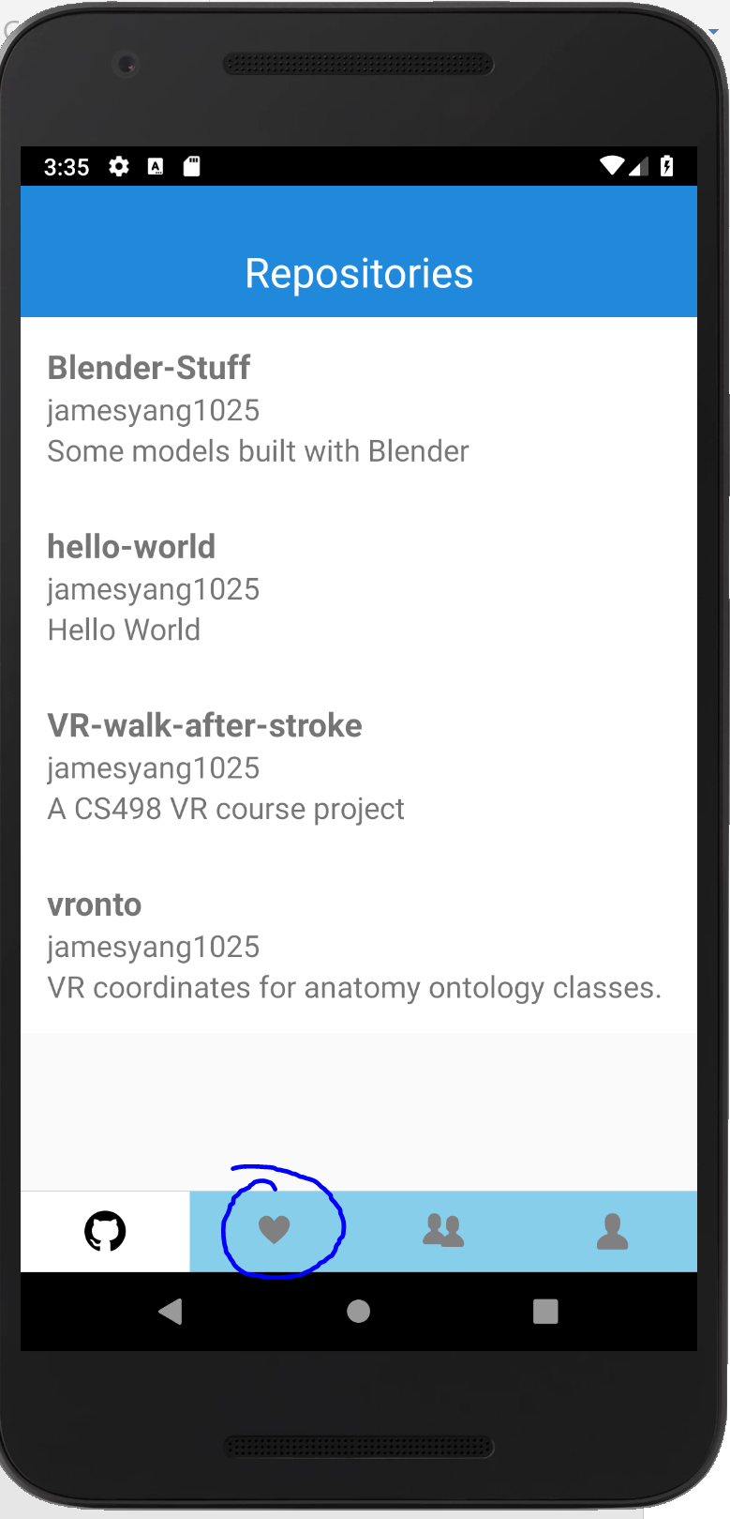 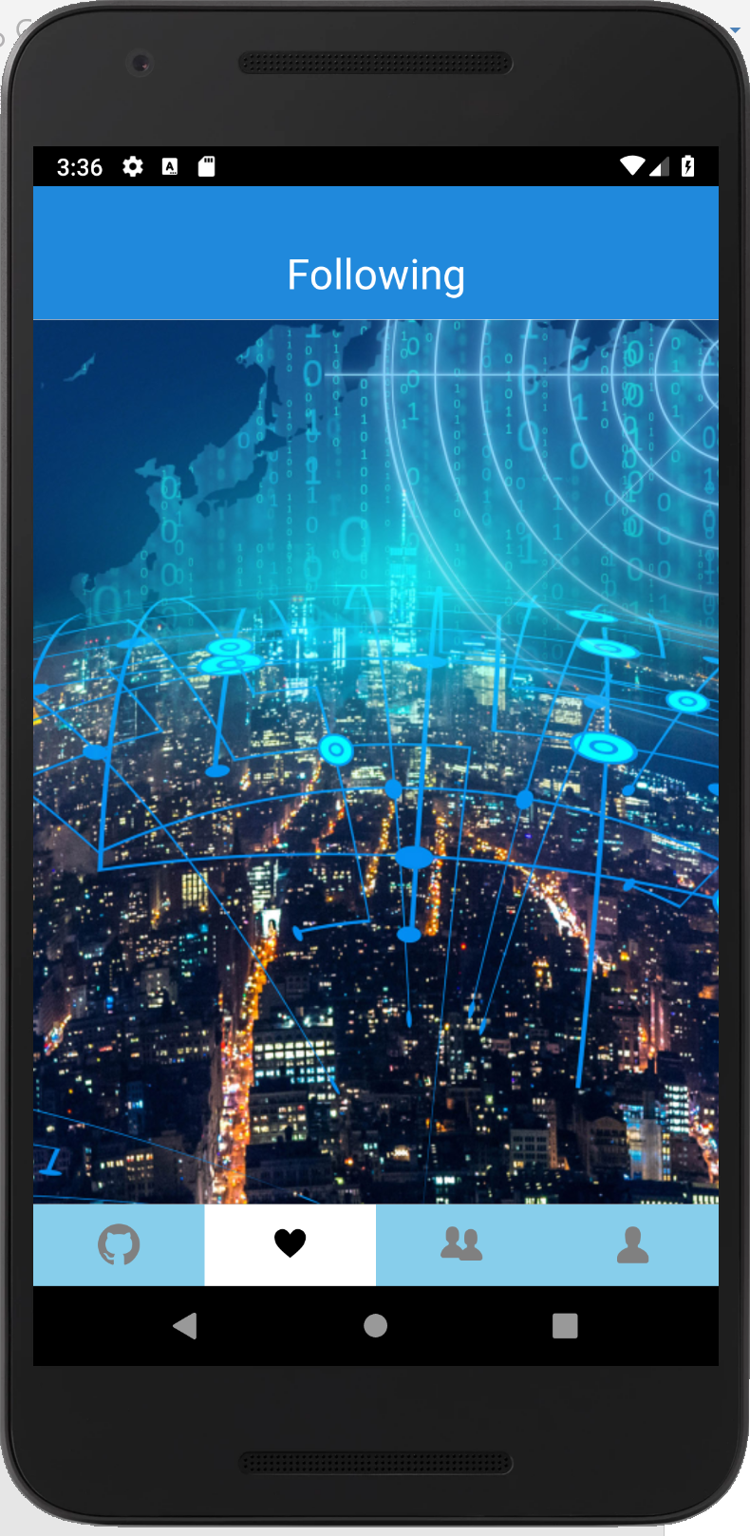

1. Similarly, click “Followers” tab, which would direct you to the “Followers page”. But at this stage, this page is empty as well.

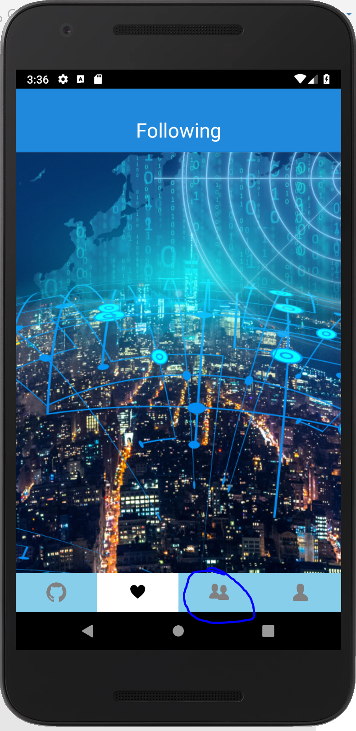 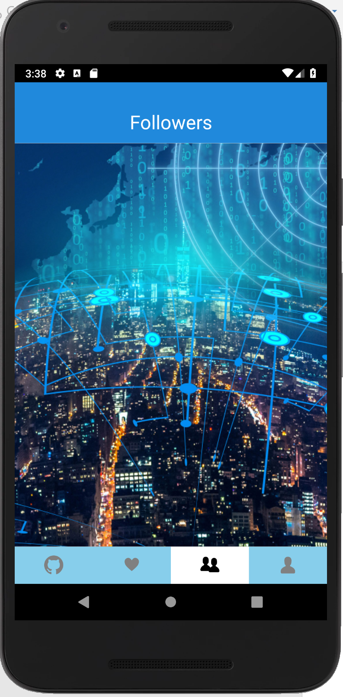

1. Click on the “Profile” tab, which will direct you to the “Profile page”. You can see the profile image, the name and username, along with numbers of repositories, following, followers, and the date the account is created.

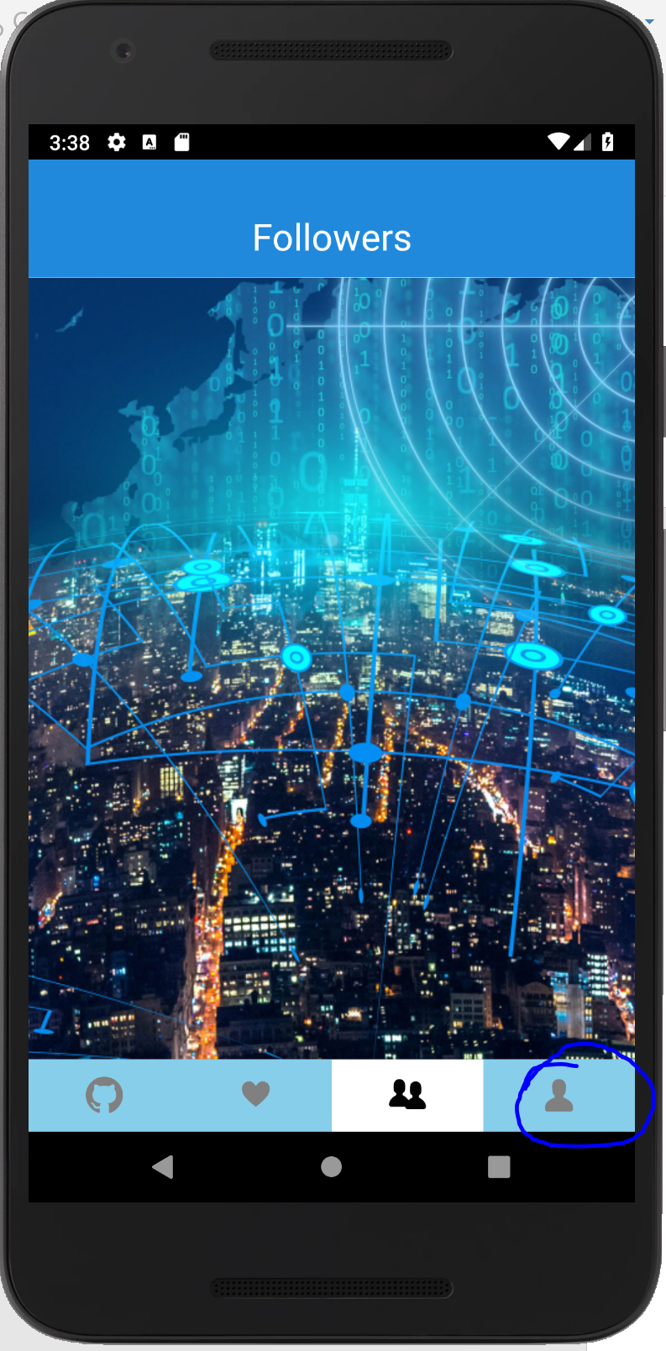 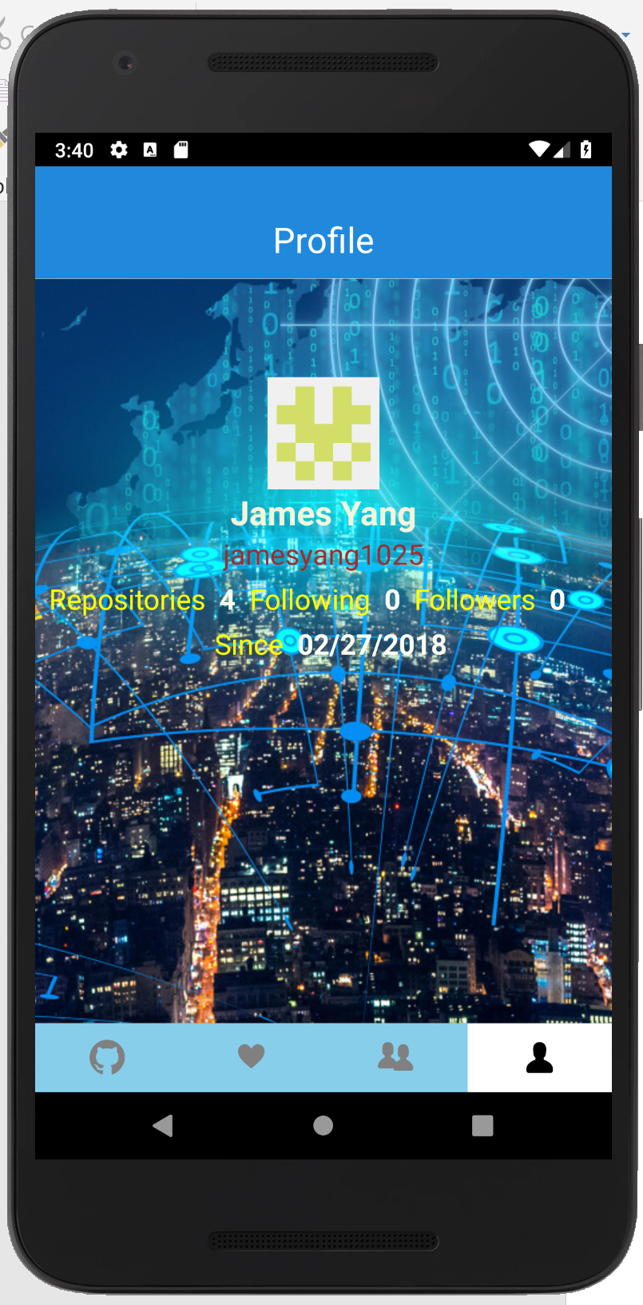

1. The number of repositories, following and followers should be clickable, which would direct you to the corresponding page.

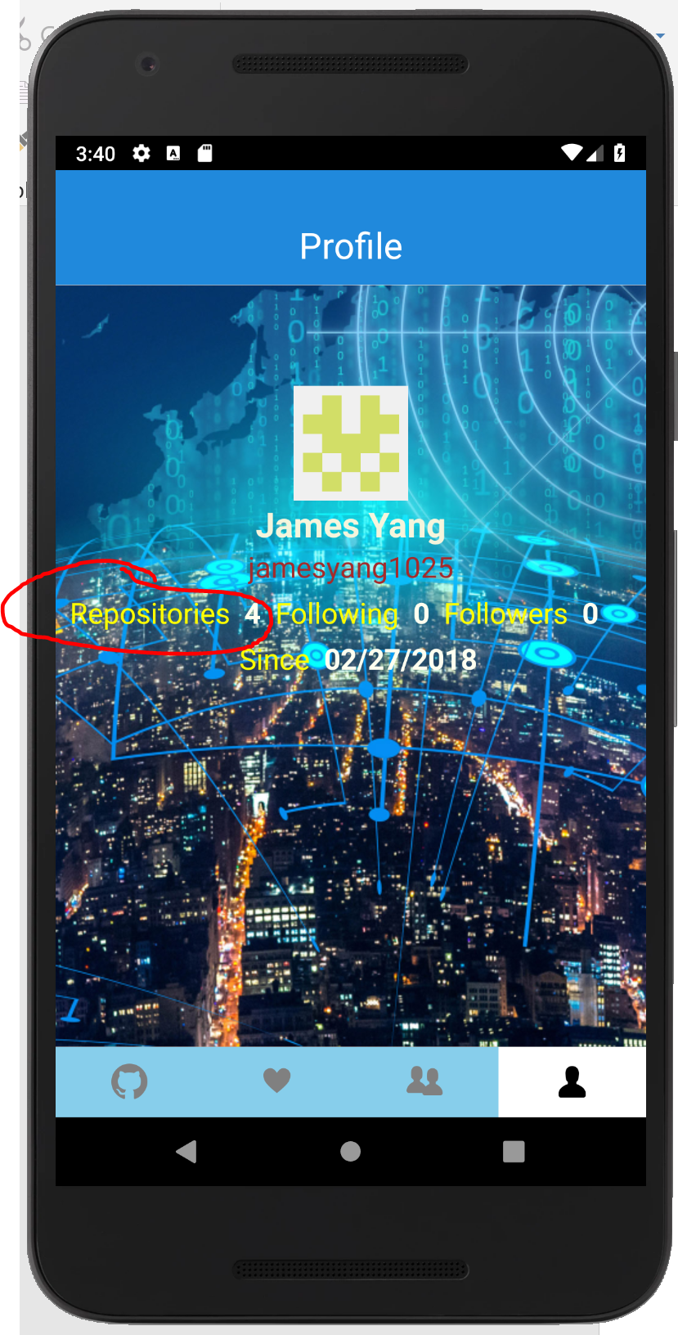 🡺 

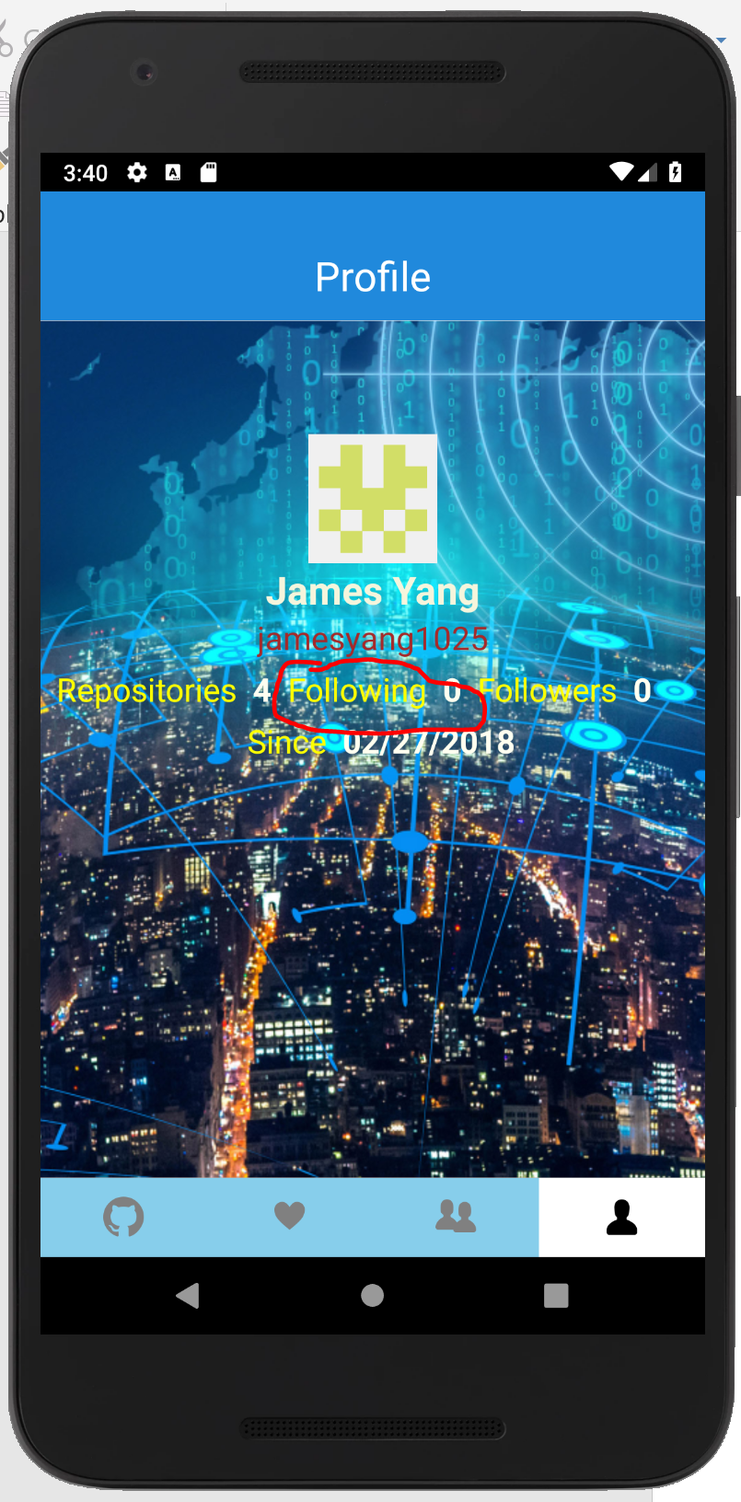 🡺 

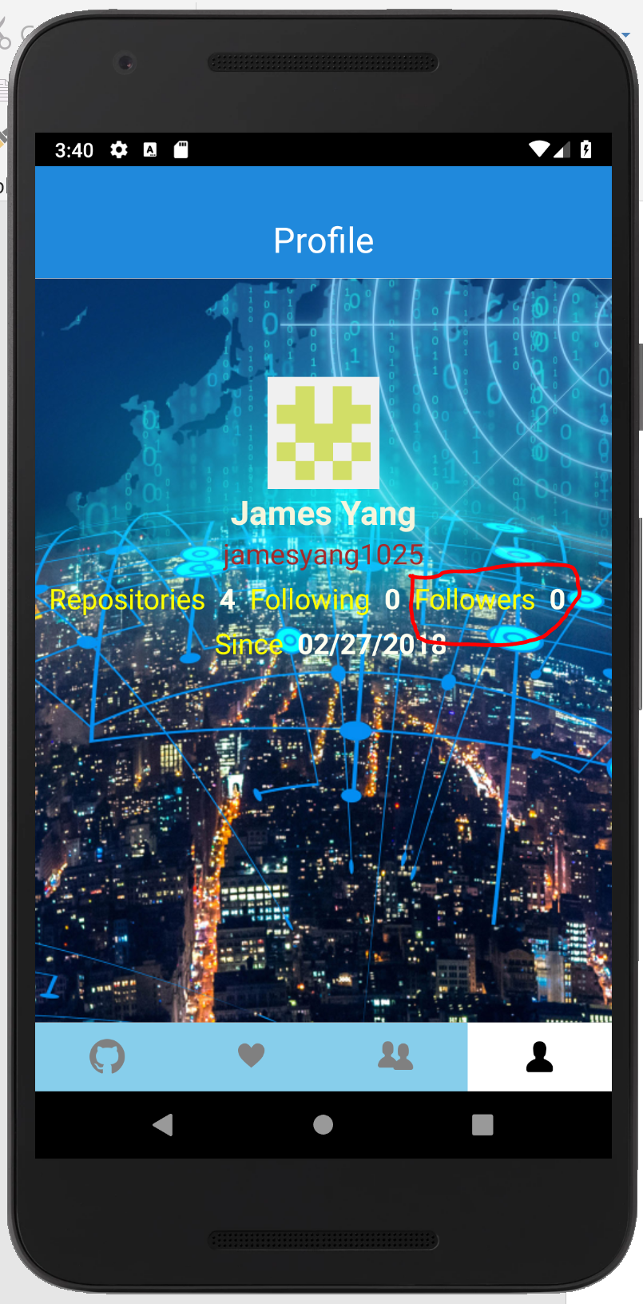 🡺 

1. The app also support adaptive layout. You can change the phone’s orientation. In emulator, click the rotate button.

